
1. Count the number of students. ( wc )

List the students having grade A. ( grep )



List the students not having grade B. ( grep )
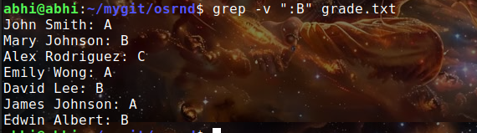

Print the count of students not having grade C. ( grep )

List the student/students whose name starts with E & having grade B. ( grep

Show only Studetns first name & Last Name. ( cut )

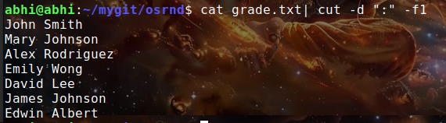
Show only grades. ( cut )

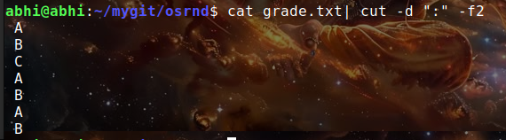
Show only first name & grades. ( cut )
